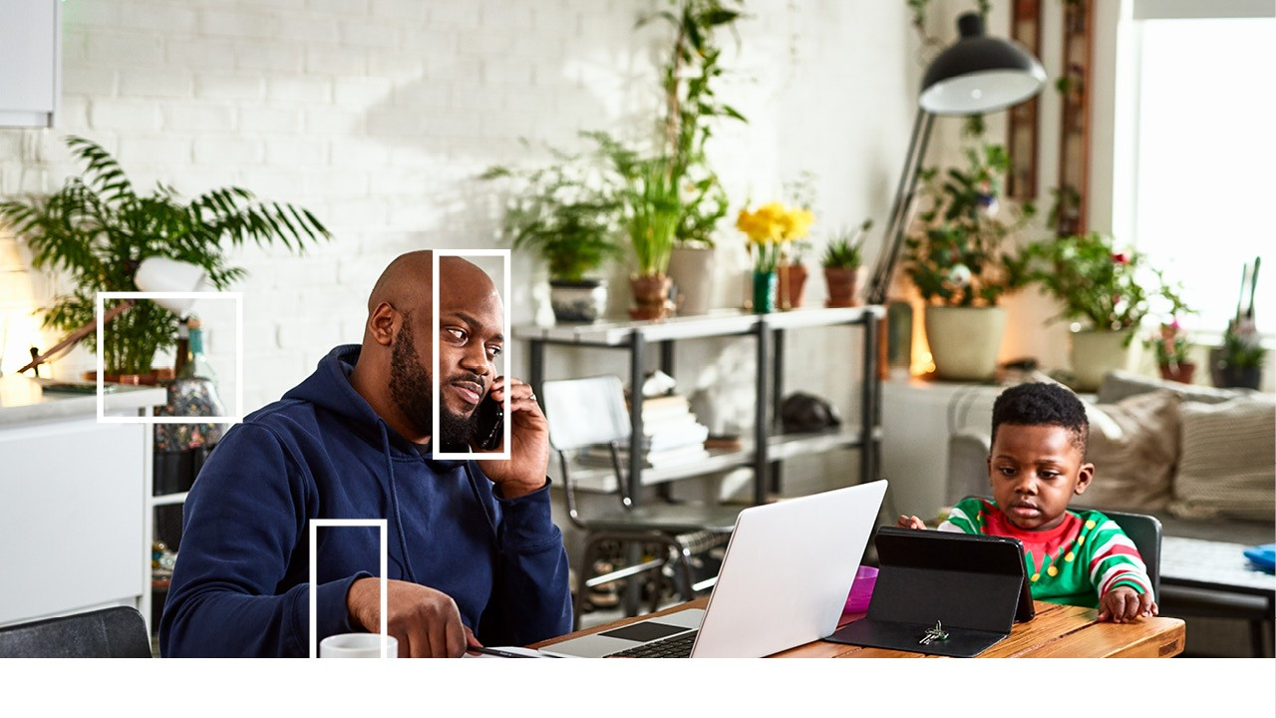
Work Safe at Home
Because Your Safety Matters

Want more energy, efficiency and better health? Working from home can have some challenges.
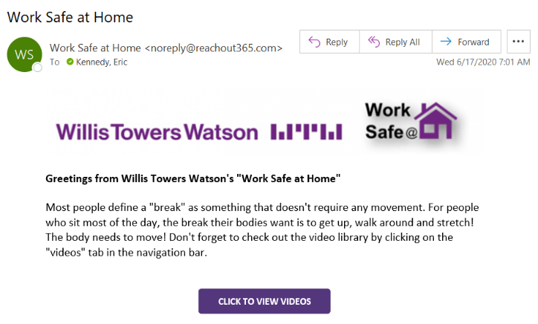
That is why we are providing you with a subscription to the Work Safe at Home video series. You’ll want to share it with your whole family.
How it Works
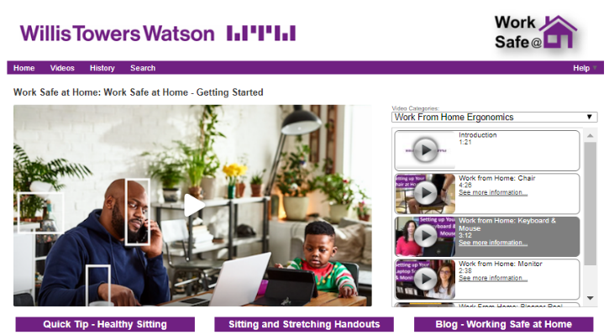
Each week you’ll receive an email that links you to dozens of short videos with tips and strategies for creating a safe and productive remote work environment. Topics include setting up your work area (chair, keyboard, etc.), tips on better sitting, household safety and other health and wellness information. The emails will arrive in your inbox with the name “Work Safe at Home” and we encourage you to take full advantage of this powerful resource.
Using the Player
No username or password is needed, just click on the link in the email and your browser will open with a selected video queued up and ready to play. Want to watch something else? Click on the “Videos” or “Search” tabs at the top to find other topics. Watch what you want when you want. You can even watch from links on your phone or tablet. Have fun and stay safe, because your safety matters!

